Jason Wang

Homework 3

1. A. i.

|  |  |  |  |
| --- | --- | --- | --- |
| A | B | C | Output |
| 0 | 0 | 0 | 1 |
| 0 | 0 | 1 | 1 |
| 0 | 1 | 0 | 1 |
| 0 | 1 | 1 | 0 |
| 1 | 0 | 0 | 1 |
| 1 | 0 | 1 | 0 |
| 1 | 1 | 0 | 1 |
| 1 | 1 | 1 | 1 |
|  | | | |

ii.

|  |  |  |  |
| --- | --- | --- | --- |
| A | B | C | Output |
| 0 | 0 | 0 | 0 |
| 0 | 0 | 1 | 1 |
| 0 | 1 | 0 | 1 |
| 0 | 1 | 1 | 1 |
| 1 | 0 | 0 | 1 |
| 1 | 0 | 1 | 1 |
| 1 | 1 | 0 | 0 |
| 1 | 1 | 1 | 0 |
|  | | | |

B.

(!A & !B & !C) | (!A & !B & C) | (A & B & !C) | (A & B & C)

((!A & !B) & !C) | ((!A & !B) & C) | ((A & B) & !C) | ((A & B) & C)

Which can be ((!A & !B) & (!C | C)) | ((A&B) & (!C | C))

Then **(!A & !B) | (A & B)**

Thus it is:

**A XNOR B**

1. A. start = 00, saw 1 = 01, saw 13 = 10, saw 132 = 11

|  |  |  |  |
| --- | --- | --- | --- |
| Current State | Input | Next State | Output |
| Start | 1 | Saw 1 | 0 (closed) |
| Start | Not 1 | Start | 0 |
| Saw 1 | 3 | Saw 13 | 0 |
| Saw 1 | Not 3 | Start | 0 |
| Saw 13 | 2 | Saw 132 | 0 |
| Saw 13 | Not 2 | Start | 0 |
| Saw 132 | 5 | Start | 1 |
| Saw 132 | Not 5 | Start | 0 |

|  |  |  |  |  |  |  |  |  |  |  |
| --- | --- | --- | --- | --- | --- | --- | --- | --- | --- | --- |
| Q1 | Q0 | | In2 | In1 | In0 | | D1 | D0 | Output | |
| 0 | 0 | | 0 | 0 | 1 | | 0 | 1 | 0 | |
| 0 | 0 | | Not 1 | | | | 0 | 0 | 0 | |
| 0 | 1 | | 0 | 1 | 1 | | 1 | 0 | 0 | |
| 0 | 1 | | Not 3 | | | | 0 | 0 | 0 | |
| 1 | 0 | | 0 | 1 | 0 | | 1 | 1 | 0 | |
| 1 | 0 | | Not 2 | | | | 0 | 0 | 0 | |
| 1 | 1 | | 1 | 0 | 1 | | 0 | 0 | 1 | |
| 1 | 1 | | Not 5 | | | | 0 | 0 | 0 | |
|  | |  | |  | |  | |  | |

Output = (Q1 & Q0 & In2 & !In1 & In0)

D1 = (!Q1 & Q0 & !In2 & In1 & In0) + (Q1 & !Q0 & !In2 & In1 & !In0)

D0 = (!Q1 & !Q0 & !In2 & !In1 & In0) + (Q1 & !Q0 & !In2 & In1 & !In0)

1/0

5/1

Not 3/0

Not 5/0

Not 5/0

Start

Not 2/0

2/0

Saw 132

3/0

Saw 13

Saw 1

B. State: 0 = 000, 5 = 001, 10 = 010, 15 = 011, 20 = 100, 25 = 101

Input: 0 = 00, N = 01, D = 10, Q = 11

|  |  |  |  |
| --- | --- | --- | --- |
| Current State | Input | Next State | Output |
| 0 | 0 | 0 | 0 (closed) |
| 0 | 5 | 5 | 0 |
| 0 | 10 | 10 | 0 |
| 0 | 25 | 25 | 0 |
| 5 | 0 | 5 | 0 |
| 5 | 5 | 10 | 0 |
| 5 | 10 | 15 | 0 |
| 5 | 25 | 0 | 1 |
| 10 | 0 | 10 | 0 |
| 10 | 5 | 15 | 0 |
| 10 | 10 | 20 | 0 |
| 10 | 25 | 0 | 1 |
| 15 | 0 | 15 | 0 |
| 15 | 5 | 20 | 0 |
| 15 | 10 | 25 | 0 |
| 15 | 25 | 0 | 1 |
| 20 | 0 | 20 | 0 |
| 20 | 5 | 25 | 0 |
| 20 | 10 | 0 | 1 |
| 20 | 25 | 0 | 1 |
| 25 | 0 | 25 | 0 |
| 25 | Not 0 | 0 | 1 |

|  |  |  |  |  |  |  |  |  |
| --- | --- | --- | --- | --- | --- | --- | --- | --- |
| Q2 | Q1 | Q0 | In1 | In0 | D2 | D1 | D0 | Output |
| 0 | 0 | 0 | 0 | 0 | 0 | 0 | 0 | 0 |
| 0 | 0 | 0 | 0 | 1 | 0 | 0 | 1 | 0 |
| 0 | 0 | 0 | 1 | 0 | 0 | 1 | 0 | 0 |
| 0 | 0 | 0 | 1 | 1 | 1 | 0 | 1 | 0 |
| 0 | 0 | 1 | 0 | 0 | 0 | 0 | 1 | 0 |
| 0 | 0 | 1 | 0 | 1 | 0 | 1 | 0 | 0 |
| 0 | 0 | 1 | 1 | 0 | 0 | 1 | 1 | 0 |
| 0 | 0 | 1 | 1 | 1 | 0 | 0 | 0 | 1 |
| 0 | 1 | 0 | 0 | 0 | 0 | 1 | 0 | 0 |
| 0 | 1 | 0 | 0 | 1 | 0 | 1 | 1 | 0 |
| 0 | 1 | 0 | 1 | 0 | 1 | 0 | 0 | 0 |
| 0 | 1 | 0 | 1 | 1 | 0 | 0 | 0 | 1 |
| 0 | 1 | 1 | 0 | 0 | 0 | 1 | 1 | 0 |
| 0 | 1 | 1 | 0 | 1 | 1 | 0 | 0 | 0 |
| 0 | 1 | 1 | 1 | 0 | 1 | 0 | 1 | 0 |
| 0 | 1 | 1 | 1 | 1 | 0 | 0 | 0 | 1 |
| 1 | 0 | 0 | 0 | 0 | 1 | 0 | 0 | 0 |
| 1 | 0 | 0 | 0 | 1 | 1 | 0 | 1 | 0 |
| 1 | 0 | 0 | 1 | 0 | 0 | 0 | 0 | 1 |
| 1 | 0 | 0 | 1 | 1 | 0 | 0 | 0 | 1 |
| 1 | 0 | 1 | 0 | 0 | 1 | 0 | 1 | 0 |
| 1 | 0 | 1 | Not 0 | | 0 | 0 | 0 | 1 |

Output = (!Q2 & !Q1 & Q0 & In1 & In0) + (!Q2 & Q1 & !Q0 & In1 & In0) + (!Q2 & Q1 & Q0 & In1 & In0) + (Q2 & !Q1 & !Q0 & In1 & !In0) + (Q2 & !Q1 & !Q0 & In1 & In0) + (Q2 & !Q1 & Q0 & !In1 & In0) + (Q2 & !Q1 & Q0 & In1 & !In0) + (Q2 & !Q1 & Q0 & In1 & In0)

D2 = (!Q2 & !Q1 & !Q0 & In1 & In0) + (!Q2 & Q1 & !Q0 & In1 & !In0) + (!Q2 & Q1 & Q0 & !In1 & In0) + (!Q2 & Q1 & Q0 & In1 & !In0) + (Q2 & !Q1 & !Q0 & !In1 & !In0) + (Q2 & !Q1 & !Q0 & !In1 & In0) + (Q2 & !Q1 & Q0 & !In1 & !In0)

D1 = (!Q2 & !Q1 & !Q0 & In1 & !In0) + (!Q2 & !Q1 & Q0 & !In1 & In0) + (!Q2 & !Q1 & Q0 & In1 & !In0) + (!Q2 & Q1 & !Q0 & !In1 & !In0) + (!Q2 & Q1 & !Q0 & !In1 & In0) + (!Q2 & Q1 & Q0 & !In1 & !In0)

D0 = (!Q2 & !Q1 & !Q0 & !In1 & In0) + (!Q2 & !Q1 & !Q0 & In1 & In0) + (!Q2 & !Q1 & Q0 & !In1 & !In0) + (!Q2 & !Q1 & Q0 & In1 & !In0) + (!Q2 & Q1 & !Q0 & !In1 & In0) + (!Q2 & Q1 & Q0 & !In1 & !In0) + (!Q2 & Q1 & Q0 & In1 & !In0) + (Q2 & !Q1 & !Q0 & !In1 & In0) + (Q2 & !Q1 & Q0 & !In1 & !In0)

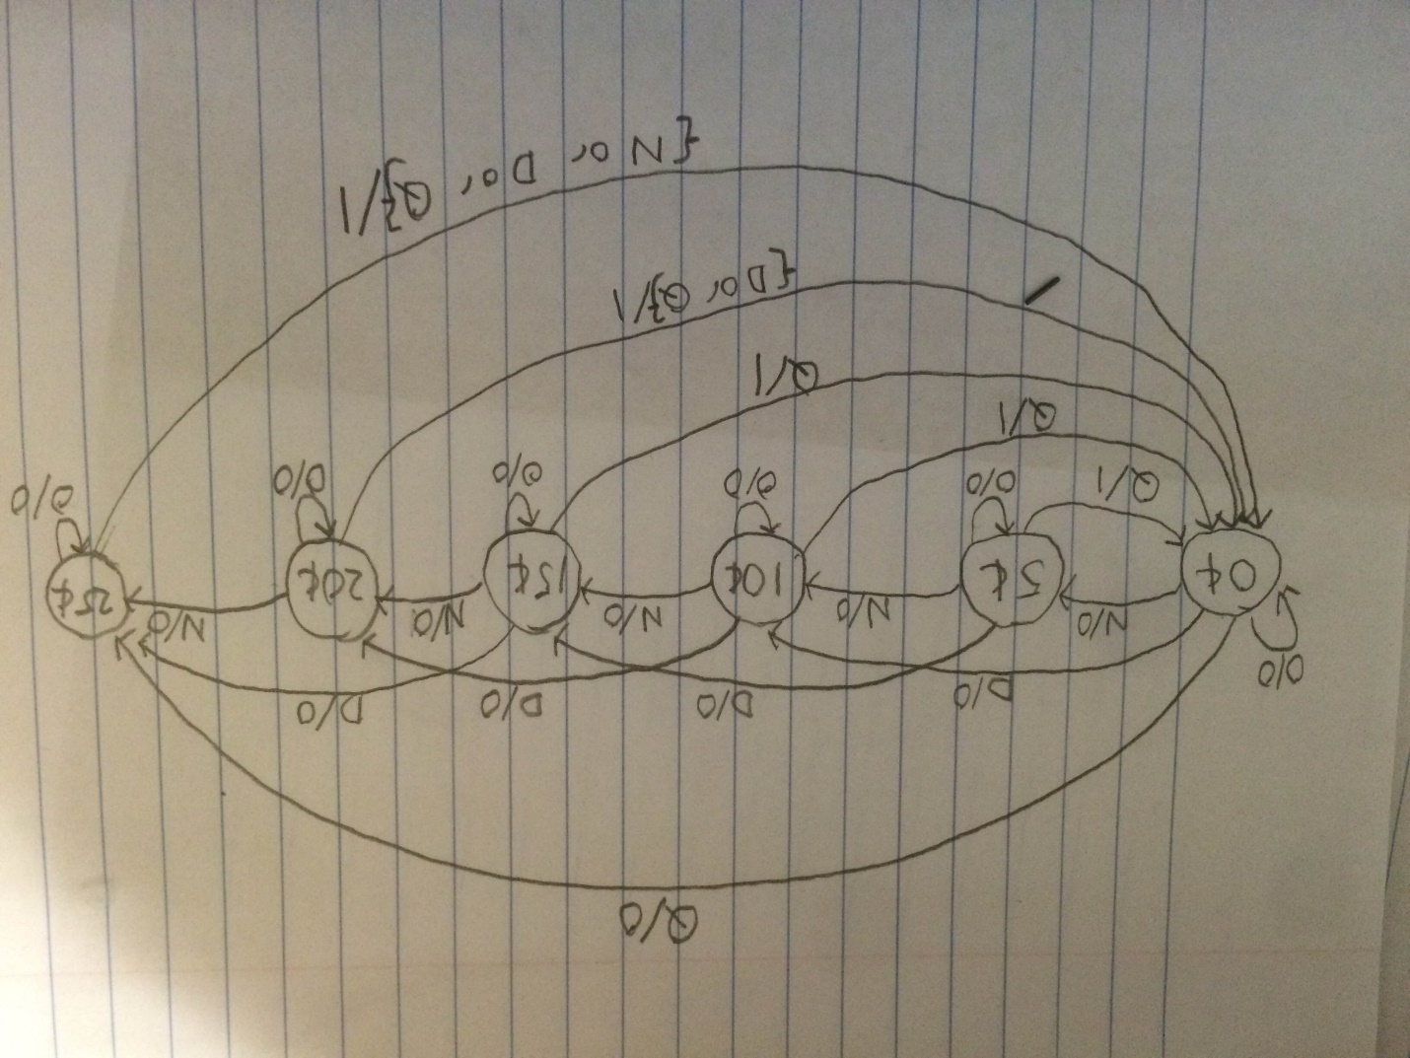

3e.

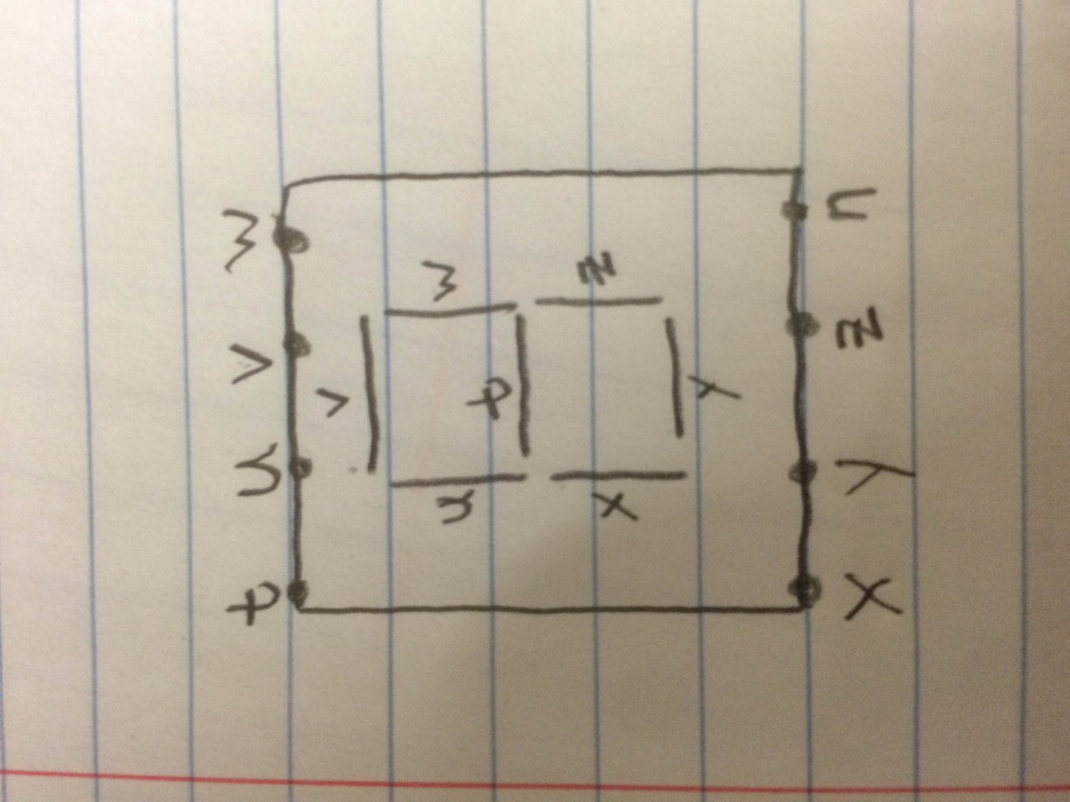

|  |  |  |  |  |  |  |  |  |  |  |  |
| --- | --- | --- | --- | --- | --- | --- | --- | --- | --- | --- | --- |
| In3 | In2 | In1 | In0 | t | u | v | w | x | y | z |  |
| 0 | 0 | 0 | 0 | 0 | 1 | 1 | 1 | 1 | 1 | 1 | 0 |
| 0 | 0 | 0 | 1 | 0 | 0 | 0 | 1 | 0 | 0 | 1 | 1 |
| 0 | 0 | 1 | 0 | 1 | 0 | 1 | 1 | 1 | 1 | 0 | 2 |
| 0 | 0 | 1 | 1 | 1 | 0 | 1 | 1 | 0 | 1 | 1 | 3 |
| 0 | 1 | 0 | 0 | 1 | 1 | 0 | 1 | 0 | 0 | 1 | 4 |
| 0 | 1 | 0 | 1 | 1 | 1 | 1 | 0 | 0 | 1 | 1 | 5 |
| 0 | 1 | 1 | 0 | 1 | 1 | 1 | 0 | 1 | 1 | 1 | 6 |
| 0 | 1 | 1 | 1 | 0 | 0 | 1 | 1 | 0 | 0 | 1 | 7 |
| 1 | 0 | 0 | 0 | 1 | 1 | 1 | 1 | 1 | 1 | 1 | 8 |
| 1 | 0 | 0 | 1 | 1 | 1 | 1 | 1 | 0 | 0 | 1 | 9 |
| 1 | 0 | 1 | 0 | 1 | 1 | 1 | 1 | 1 | 0 | 1 | A |
| 1 | 0 | 1 | 1 | 1 | 1 | 0 | 0 | 1 | 1 | 1 | B |
| 1 | 1 | 0 | 0 | 1 | 0 | 0 | 0 | 1 | 1 | 0 | C |
| 1 | 1 | 0 | 1 | 1 | 0 | 0 | 1 | 1 | 1 | 1 | D |
| 1 | 1 | 1 | 0 | 1 | 1 | 1 | 0 | 1 | 1 | 0 | E |
| 1 | 1 | 1 | 1 | 1 | 1 | 1 | 0 | 1 | 0 | 0 | F |

t = (!In3 & !In2 & In1 & !In0) + (!In3 & !In2 & In1 & In0) + (!In3 & In2 & !In1 & !In0) + (!In3 & In2 & !In1 & In0) + (!In3 & In2 & In1 & !In0) + (In3 & !In2 & !In1 & !In0) + (In3 & !In2 & !In1 & In0) + (In3 & !In2 & In1 & !In0) + (In3 & !In2 & In1 & In0) + (In3 & In2 & !In1 & !In0) + (In3 & In2 & !In1 & In0) + (In3 & In2 & In1 & !In0) + (In3 & In2 & In1 & In0)

u = (!In3 & !In2 & !In1 & !In0) + (!In3 & In2 & !In1 & !In0) + (!In3 & In2 & !In1 & In0) + (!In3 & In2 & In1 & !In0) + (In3 & !In2 & !In1 & !In0) + (In3 & !In2 & !In1 & In0) + (In3 & !In2 & In1 & !In0) + (In3 & !In2 & In1 & In0) + (In3 & In2 & In1 & !In0) + (In3 & In2 & In1 & In0)

v = (!In3 & !In2 & !In1 & !In0) + (!In3 & !In2 & In1 & !In0) + (!In3 & !In2 & In1 & In0) + (!In3 & In2 & !In1 & In0) + (!In3 & In2 & In1 & !In0) + (!In3 & In2 & In1 & In0) + (In3 & !In2 & !In1 & !In0) + (In3 & !In2 & !In1 & In0) + (In3 & !In2 & In1 & !In0) + (In3 & In2 & In1 & !In0) + (In3 & In2 & In1 & In0)

w = (!In3 & !In2 & !In1 & !In0) + (!In3 & !In2 & !In1 & In0) + (!In3 & !In2 & In1 & !In0) + (!In3 & !In2 & In1 & In0) + (!In3 & In2 & !In1 & !In0) + (!In3 & In2 & In1 & In0) + (In3 & !In2 & !In1 & !In0) + (In3 & !In2 & !In1 & In0) + (In3 & !In2 & In1 & !In0) + (In3 & In2 & !In1 & In0)

x = (!In3 & !In2 & !In1 & !In0) + (!In3 & !In2 & In1 & !In0) +(!In3 & In2 & In1 & !In0) + (In3 & !In2 & !In1 & !In0) + (In3 & !In2 & In1 & !In0) + (In3 & !In2 & In1 & In0) + (In3 & In2 & !In1 & !In0) + (In3 & In2 & !In1 & In0) + (In3 & In2 & In1 & !In0) + (In3 & In2 & In1 & In0)

y = (!In3 & !In2 & !In1 & !In0) + (!In3 & !In2 & In1 & !In0) + (!In3 & !In2 & In1 & In0) + (!In3 & In2 & !In1 & In0) + (!In3 & In2 & In1 & !In0) + (In3 & !In2 & !In1 & !In0) + (In3 & !In2 & In1 & In0) + (In3 & In2 & !In1 & !In0) + (In3 & In2 & !In1 & In0) + (In3 & In2 & In1 & !In0)

z = (!In3 & !In2 & !In1 & !In0) + (!In3 & !In2 & !In1 & In0) + (!In3 & !In2 & In1 & In0) + (!In3 & In2 & !In1 & !In0) + (!In3 & In2 & !In1 & In0) + (!In3 & In2 & In1 & !In0) + (!In3 & In2 & In1 & In0) + (In3 & !In2 & !In1 & !In0) + (In3 & !In2 & !In1 & In0) + (In3 & !In2 & In1 & !In0) + (In3 & !In2 & In1 & In0) + (In3 & In2 & !In1 & In0)